

# Oricom Care80 Amplified Phone with Picture Dialling

## Type of device: Landline - Standard

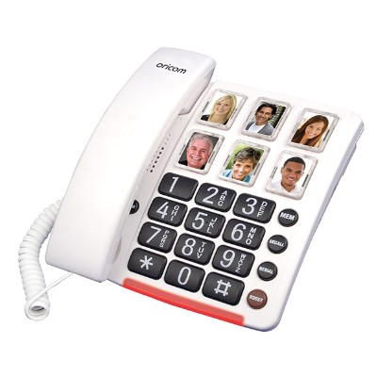

Button Type : Physical Keypad

Average Price : $90 as of 15 06 2021

## Accessibility Features:

### Cognitive

Photo Telephone List

### Hearing Impairment and Deaf

* Hearing Aid Telecoil Coupling

Visual Alerts - Incoming Calls

### Vision

* Key Marker – Raised '5'
* Key Numbers - Standard Layout

Key Press - Vibration or Click

### Physical

* Flat Back for Table Top Operation
* Physical Dialling Keys

Speaker-phone option

## How and where to get it from?

You can buy this phone from [Oricom](https://oricom.com.au/product/care80-amplified-phone-picture-dialling/), and other retailers.

## More information is available on:

[Oricom Care80 Specifications (PDF Download)](https://oricom.com.au/wp-content/uploads/2017/04/CARE80-Spec-Sheet-NEW.pdf)

[Oricom Care80 User Manual (PDF Download)](https://oricom.com.au/wp-content/uploads/2017/04/CARE80-Amplified-Phone-with-Picture-Dialling-User-Guide.pdf)